PUZZLES OF DISTRACTION

1. White mates/ Black wins
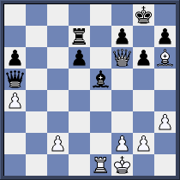

W:

B:

2. White mates/ Black mates
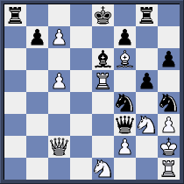

W:

B:

3. White wins/ Black mates
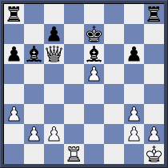

W:

B:

4. White mates/ Black wins
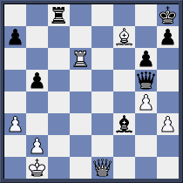

W:

B:

5. White mates/ Black mates
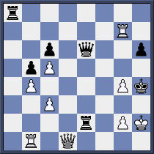

W:

B:

6. White wins/ Black wins
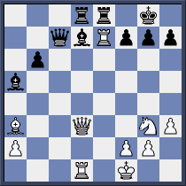

W:

B:

